“Property Listing Management & Analytics Portal for Real Estate”
A Project Report Submitted in the partial fulfillment of the requirements for the award of the degree of
BACHELOR OF TECHNOLOGY
In
DEPARTMENT OF COMPUTER SCIENCE ENGINEERING
&
DEPARTMENT OF COMPUTER SCIENCE AND INFORMATION TECHNOLOGY
By
P. NITHYA SAI | 2520030517
M. POOJITHA | 2520030541
D. NAMITH RAO | 2520030249
Under the Esteemed Guidance of
Dr. R. Sateesh Kumar
Department of Computer Science and Engineering



Academic Year 2026–2027

K L (Deemed to be) University
DEPARTMENT OF COMPUTER SCIENCE ENGINEERING

DEPARTMENT OF COMPUTER SCIENCE AND INFORMATION TECHNOLOGY

DECLARATION
The project report entitled “Property Listing Management & Analytics Portal for Real Estate” is a record of work prepared by the following students in partial fulfillment of the requirements for the award of the Bachelor of Technology degree. The report describes the proposed system, its requirements, design, implementation approach, validation plan, and expected outcomes. Any implementation status, measurements, or deployment claims should be read in accordance with the actual project artifacts and evaluation evidence maintained by the team.
P. Nithya Sai – 2520030517
M. Poojitha – 2520030541
D. Namith Rao – 2520030249

CERTIFICATE
This is to certify that the project report entitled “Property Listing Management & Analytics Portal for Real Estate” is submitted by P. Nithya Sai (2520030517), M. Poojitha (2520030541), and D. Namith Rao (2520030249), in partial fulfillment of the requirements for the award of the degree of Bachelor of Technology. The work is presented under the guidance of Dr Yerragudipadu Subbarayudu, Assistant Professor, Department of Computer Science and Engineering.
Signature of the Guide | Signature of the Course Coordinator | Signature of the HOD

ACKNOWLEDGEMENT
We express our sincere gratitude to our project guide, Dr Yerragudipadu Subbarayudu, Assistant Professor, Department of Computer Science and Engineering, for his guidance, encouragement, and valuable suggestions throughout the planning and documentation of this project.
We thank the Department of Computer Science Engineering and the Department of Computer Science and Information Technology, K L (Deemed to be) University, for providing the academic environment and facilities required for this work. We are also grateful to our faculty members, classmates, friends, and families for their support and feedback.
The project is a collaborative effort by P. Nithya Sai, M. Poojitha, and D. Namith Rao. We acknowledge the importance of careful requirement analysis, responsible handling of property information, and honest reporting of system capabilities in developing a useful real-estate information portal.
P. Nithya Sai – 2520030517
M. Poojitha – 2520030541
D. Namith Rao – 2520030249

ABSTRACT
Property seekers often need to compare real-estate projects across price, location, configuration, area, amenities, possession timelines, and other attributes. When information is distributed across separate listings and promotional pages, users may find it difficult to evaluate alternatives consistently. Property Listing Management & Analytics Portal for Real Estate is designed as a centralized web application for organizing property listings, searching and filtering available projects, comparing selected properties side by side, and presenting summary analytics to authorized users.
The proposed portal has two principal perspectives. The buyer-facing interface supports discovery, structured property details, shortlisting, and inquiry submission. The management-facing interface supports listing creation and maintenance, data-quality checks, status management, and high-level analytics. A role-aware application layer separates public browsing from administrative operations, while a structured data store supports consistent retrieval and comparison.
The report documents the problem statement, objectives, functional and non-functional requirements, system architecture, data model, interface design, implementation plan, testing strategy, limitations, and future enhancements. The precise technology stack and completion status should be aligned with the team’s actual source code and demonstration environment before final academic submission.
Keywords: Real estate, property listings, project comparison, analytics dashboard, search and filtering, listing management.

TABLE OF CONTENTS
- Introduction
- System Requirements Specification
- Technology and Tools
- System Architecture
- System Design
- Data Model and Database Design
- Functional Modules and Features
- Implementation Approach
- Testing and Validation
- Security, Privacy and Data Quality
- Deployment and Operations
- Challenges and Limitations
- Future Enhancements
- Conclusion
References
Appendices
Note: Page numbers are generated by the final PDF layout. The report is a project documentation draft and should be reconciled with the team’s actual implementation and review feedback before submission.

INTRODUCTION

Background
Real-estate decisions involve multiple attributes that are not always presented in a consistent format. A user may need to review location, property type, built-up area, price, amenities, developer, status, and possession details across several projects. A structured portal can reduce repetitive browsing by bringing these attributes into a searchable catalogue and offering a common comparison view.

Problem Statement
The project addresses the difficulty of discovering and comparing property projects when listing information is fragmented, inconsistently formatted, or difficult to evaluate side by side. It also addresses the operational need for a central place to maintain listing details and observe basic catalogue-level trends.

Objectives
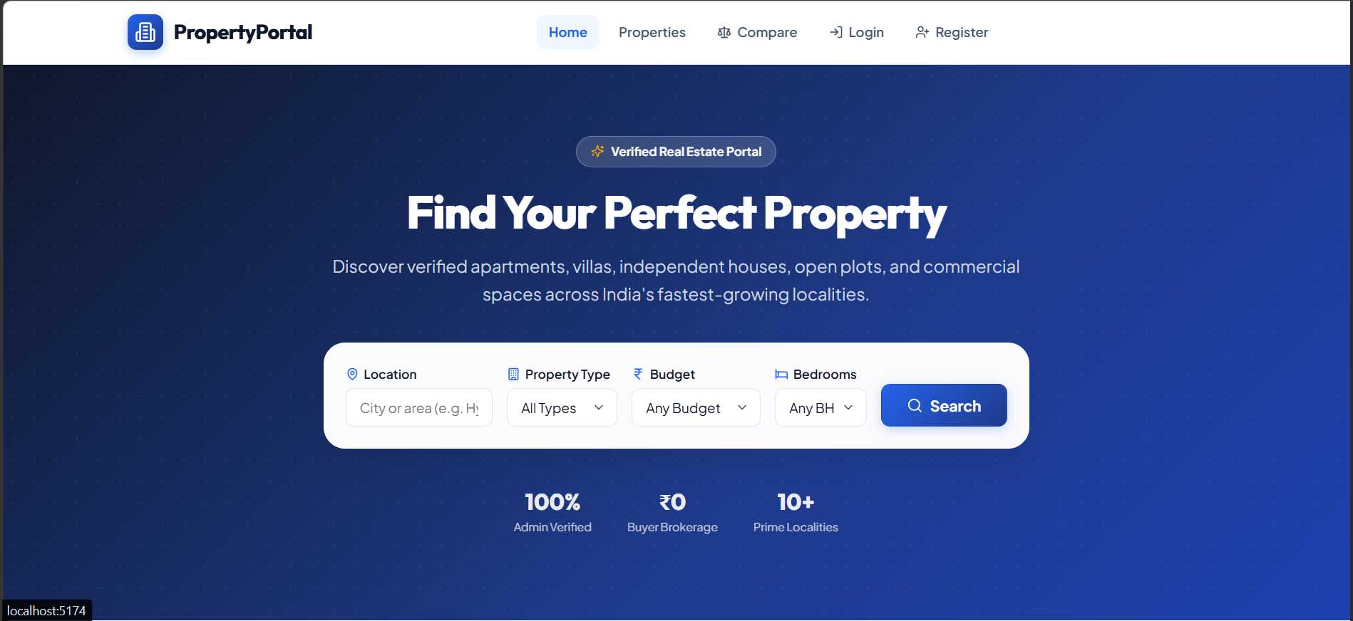
Figure 1.1: PropertyPortal Home Page
The primary objectives are to: provide a centralized property catalogue; support keyword search and attribute-based filters; display detailed listing pages; enable side-by-side comparison; allow users to save shortlisted properties and submit inquiries; provide administrators with listing-management workflows; and summarize catalogue information through clear analytics.

Scope
The portal focuses on information discovery and listing administration. It is not intended to replace legal due diligence, property inspection, valuation by a qualified professional, or verification of title and regulatory approvals. Listing data must be sourced, reviewed, and updated responsibly.

Intended Users

Importance of the Application
The Property Listing Management & Analytics Portal is important because property information is often spread across multiple listing pages and may be presented in different formats. A centralized portal brings property attributes, search, filtering, comparison, shortlisting, enquiries, and administrative management into one system. This reduces repetitive searching and gives users a structured way to review available information.
For buyers and other property seekers, the application provides a convenient catalogue and a common format for comparing properties. For owners and agents, it provides a controlled place to maintain listing information. For administrators, it provides role-aware management, verification workflows, enquiry monitoring, and analytics. The system therefore supports both property discovery and listing administration within the same application.

Target Users / Audience
The target audience consists of four principal user roles: Buyer, Owner, Agent, and Admin. Buyers can browse and evaluate properties, save favourites, and submit enquiries. Owners can manage their own property listings and keep listing information updated. Agents can manage listings and enquiries according to the permissions assigned to their accounts. Administrators have broader control over users, property verification, listing status, enquiries, activity records, and analytics.
The role-based structure is intended to keep the interface relevant to each user while restricting administrative operations to authorized accounts. The application can also be used by project evaluators and academic reviewers to demonstrate property search, listing management, database interaction, and analytics workflows.

The main users are prospective buyers or renters, property consultants, listing administrators, and project evaluators. Public users need clear and accessible information. Administrators need controlled editing and data-quality tools. Evaluators need traceable demonstrations and test evidence.

SYSTEM REQUIREMENTSSPECIFICATION

Functional Requirements
The system shall display a searchable catalogue of active listings; filter results by location, property type, price range, area, bedrooms/configuration, amenities, and status where data is available; open a detailed property page; select multiple projects for comparison; save or remove shortlist items for an authenticated user; submit an inquiry; and allow authorized administrators to create, edit, publish, archive, and review listings.

Administrative Requirements
Administrative functions should include authentication, role checks, required-field validation, duplicate or near-duplicate detection, image and document metadata management, status changes, and a record of important changes. Destructive operations should require confirmation and should be auditable where feasible.

Non-Functional Requirements
Usability: common tasks should be understandable without training. Performance: search and listing pages should respond promptly for the expected project dataset. Reliability: invalid data should be rejected and failures should produce useful messages. Security: privileged actions must require authorization. Maintainability: modules should be separated and documented.
Accessibility: forms, controls, and tables should support keyboard use and readable contrast.

Constraints and Assumptions

Hardware Requirements
The project is a web-based application and can be developed and demonstrated on a standard laptop or desktop computer. A modern multi-core processor, at least 8 GB RAM, sufficient SSD storage for the source code and database, keyboard and mouse, and a stable internet connection are suitable for development. End users require only a device capable of running a modern web browser. Server-side hardware requirements depend on the number of simultaneous users and the size of the property dataset.

Software Requirements
The confirmed implementation uses React.js for the frontend, Node.js with Express.js for the backend, and MySQL for database management. Visual Studio Code can be used as the development environment. A modern browser such as Google Chrome, Microsoft Edge, or Mozilla Firefox is required for accessing the web application. Node Package Manager (npm) is used to install JavaScript dependencies and run the frontend and backend development commands.

Development Tools and Frameworks
The frontend is organized as reusable React components for property cards, filters, pagination, protected routes, and other interface elements. The backend uses Node.js and Express.js to expose application services and communicate with MySQL. MySQL provides persistent storage for users, properties, favourites, enquiries, and related records. Environment configuration is kept separately from application code so that database and other configuration values are not hard-coded into source files.

Assumptions for Demonstration
The current report describes a local development and demonstration environment. The actual implementation and demonstration should be treated as the source of truth for which features are complete. External integrations, cloud hosting, email services, maps, and other third-party services should only be listed as implemented when they are present in the submitted project.

The accuracy of analytics depends on completeness and freshness of the listing data. Maps, email delivery, authentication providers, and external property feeds may require credentials or third-party services. The project should not display fabricated listings as real inventory.
Demonstration data should be clearly identified as sample data.

Use Cases
The following table summarizes the principal actors and their expected interactions.
Actor | Use case | Outcome
Visitor / buyer | Search and filter properties | A focused list of matching listings
Visitor / buyer | Compare projects | Side-by-side view of selected attributes
Registered user | Save and enquire | Saved shortlist and recorded inquiry

Actor | Use case | Outcome
Administrator | Create, edit, verify, archive listings | Maintained and moderated property catalogue
Administrator / analyst | View analytics dashboard | Summary indicators and trends

TECHNOLOGY AND TOOLS

Technology Selection Principles
The implementation stack should be chosen according to the team’s existing repository, course requirements, available hosting, and maintainability. A web-based client, an application/API layer, and a structured database form a suitable logical separation. The specific libraries and versions must be recorded from the actual project configuration rather than inferred from this report.

User Interface Layer
The interface is responsible for search controls, filters, listing cards, detail pages, comparison tables, inquiry forms, and administrative screens. Reusable components should keep property attributes consistent across catalogue and comparison views.

Application Layer
The application layer validates requests, enforces roles, applies search and comparison rules, coordinates persistence, and returns structured responses. Business rules should not be implemented only in the browser because client-side checks can be bypassed.

Data Layer
A relational data store is appropriate for structured property attributes and relationships such as users, listings, amenities, images, saved items, and inquiries. If a different database is used in the implementation, the data model should be adapted while preserving the integrity constraints described in this report.

Development and Version Control

Frontend Technology – React.js
React.js is used to build the client-side interface. The application is divided into reusable components so that common elements such as property cards, budget filters, pagination, protected routes, and navigation can be maintained independently. React state and event handlers allow filter values, selected properties, forms, and user interactions to update the interface without requiring a complete page reload.

Backend Technology – Node.js and Express.js
Node.js provides the server-side JavaScript runtime and Express.js provides the HTTP application framework. The backend receives requests from the frontend, validates input, applies business rules, performs database operations, and returns structured responses. The running project uses the backend server on the local address http://localhost:5000 during development.

Database Technology – MySQL
MySQL is used as the relational database management system. The development environment connects to a database named property_portal. A connection pool is used by the backend to manage database connections efficiently. Relational tables and foreign-key relationships support consistent storage of users, property listings, amenities, images, favourites, enquiries, and administrative records.

Version Control and Project Management
Git can be used to track source-code changes and maintain project history, while GitHub can be used for repository hosting and team collaboration when configured by the project team. Dependency lock files should be retained so that the same package versions can be reproduced during setup. Secrets and database credentials should not be committed to the repository.

The team should maintain a shared repository, use descriptive commits, document setup steps, keep secrets out of source control, and provide a reproducible local development workflow.
Dependency versions should be pinned or captured in lockfiles.

SYSTEM ARCHITECTURE

Architectural Overview
The proposed architecture separates the web client, application services, and persistent data. The client presents information and collects user input. The API layer validates requests and applies authorization and business rules. The data layer stores listing and user-related records. Optional external services may support maps, geocoding, or email notifications.

Request Flow
A typical search begins when the user enters a query or selects filters. The client sends normalized criteria to the application layer. The service validates ranges and allowed values, queries the data store, applies pagination and sorting, and returns matching records. The interface renders the results and preserves selected filter state.

Comparison Flow
The user selects a small set of listings. The application retrieves comparable attributes and normalizes units and missing values. The interface displays each selected project in a common column structure. Missing or unavailable data should be shown explicitly rather than treated as zero or silently omitted.

Architecture Diagram
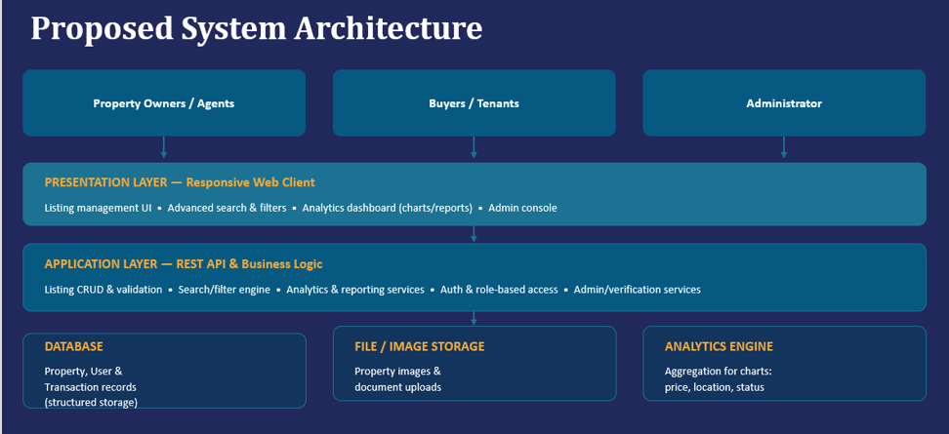Figure 4.1: System Architecture of PropertyPortal
User Interface
Web client
Application API
Validation & rules
Data Layer
Relational database
Property Services
Listings & filters
Comparison &
analytics engine
Identity &
inquiry services
External integrations (optional)
Maps • Email • Geocoding
Figure 4.1: Logical architecture of the proposed portal

Design Principles

Deployment Architecture
For local development, the frontend and backend run as separate processes. The React development server is started from the frontend directory and is normally available at http://localhost:5173. The Node.js/Express backend runs separately on http://localhost:5000 and communicates with the MySQL database named property_portal. The browser communicates with the frontend, and frontend API requests are handled by the backend before database operations are performed.
For a future hosted deployment, the frontend and backend can be deployed as separate services with a managed MySQL instance or a secured database server. Environment variables should be configured separately for development and production. HTTPS, database backups, access controls, logging, and monitoring should be added before public deployment.

Use clear boundaries between presentation, business logic, and persistence. Validate data at trust boundaries. Prefer explicit status values over ambiguous booleans. Keep analytics definitions documented. Avoid coupling the user interface to database implementation details.

SYSTEM DESIGN

Main Screens
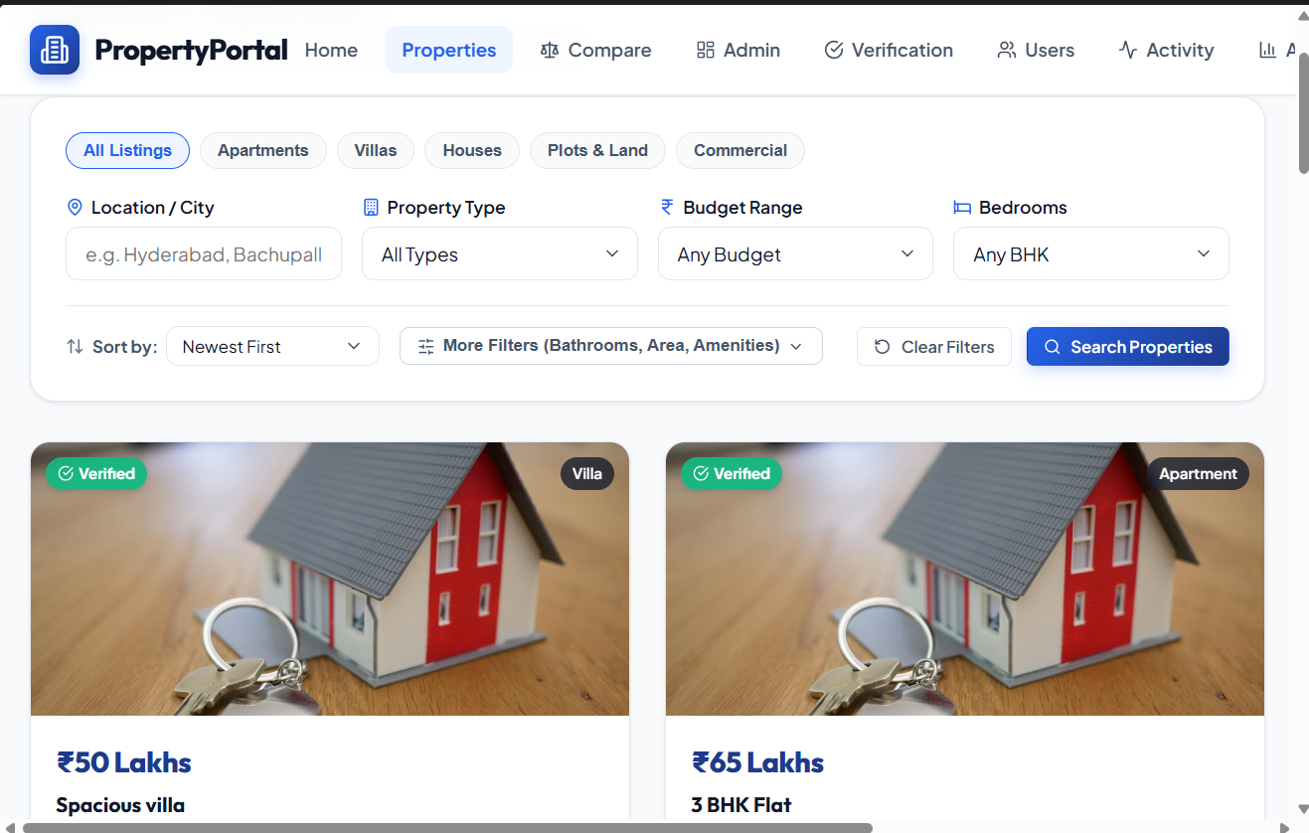
Property Search and Listing Interface
The proposed screens are: landing/search page; results page; property detail page; comparison workspace; saved properties; inquiry form and confirmation; sign-in/sign-up where required; administrator dashboard; listing editor; listing moderation view; and analytics dashboard.

Search and Filter Design
Search should support a text query and composable filters. Price and area filters should validate minimum and maximum values. Filters should be visible, removable, and reflected in the result count. Sorting options may include price, area, newest listing, or relevance, depending on available data.

Comparison Design
A comparison view should use aligned rows for location, property type, price, area, configuration, amenities, status, possession timeline, and developer. The view should indicate when a field is not supplied. Units and currency should be consistent. A user should be able to remove a project without restarting the comparison.

Dashboard Design
The dashboard may summarize active listings, listings by property type, price bands, geographic distribution, and inquiry volume over a selected period. Every chart should state its data basis and time window. Small sample sizes and incomplete records should be disclosed.

Usability and Responsive Layout

Role-Based Interface Design
The interface is designed around the permissions of the four roles. Buyer-oriented screens emphasize property discovery, filters, comparison, favourites, and enquiries. Owner and Agent workflows emphasize listing creation, editing, availability, images, and enquiry handling. Admin screens provide user management, listing verification or rejection, activity monitoring, and analytics. Protected routes and server-side authorization should work together so that restricted functions are not available to unauthorized users.

Navigation Flow
A typical buyer flow is: Home or catalogue → Search and Filters → Property Details → Compare or Favourite → Enquiry. An owner or agent flow is: Login → Dashboard → Add/Edit Listing → Manage Images and Availability → View Enquiries. An administrator flow is: Login → Admin Dashboard → Review Users/Listings → Verify or Reject Listing → Monitor Enquiries and Activity → View Analytics.

The layout should work on laptop and mobile widths. Search controls should not overwhelm the results. Forms should label every field, preserve user input after recoverable errors, and display clear success or failure states. Tables should remain usable on narrow screens through horizontal scrolling or a stacked layout.

DATA MODEL AND DATABASE DESIGN

Core Entities
The core entities are PropertyListing, User, Amenity, ListingAmenity, ListingImage, SavedProperty, Inquiry, and AuditEvent. A project may be represented as a listing or as a parent entity with multiple units, depending on the actual scope. The chosen representation should be consistent across search, detail, and comparison features.

Key Fields
A listing can include listing_id, title, description, property_type, address/location, price, currency, area_value, area_unit, bedrooms, bathrooms, amenities, developer, possession_date, status, created_at, updated_at, and verification_state. Optional fields should be nullable and clearly labelled.

Relationships
A user can save multiple listings and submit multiple inquiries. A listing can have multiple amenities and images. A many-to-many relationship between listings and amenities can be represented by a junction table. Audit events should reference the actor and affected entity where possible.

Data Integrity
Use stable identifiers, required-field constraints, valid numeric ranges, controlled status values, and foreign-key relationships. Price and area should be stored as numeric values with explicit units. Dates should use a consistent timezone policy. Avoid storing formatted display strings as the only source of numeric data.

Sample Schema
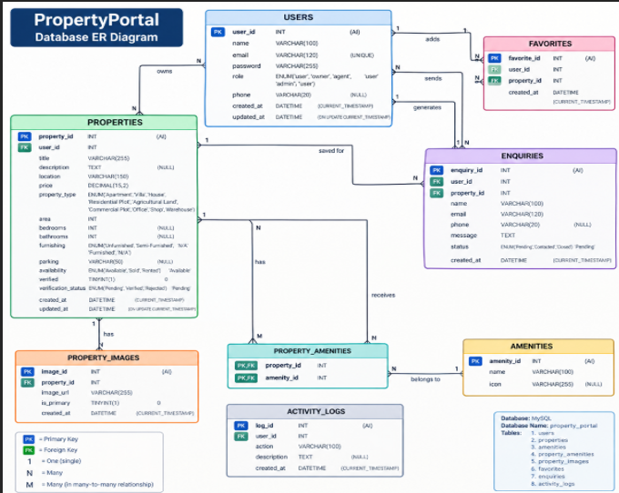
Entity Relationship Diagram of PropertyPortal Database
Entity | Representative attributes
PropertyListing | listing_id (PK), title, type, location, price, currency, area, area_unit, status, updated_at
User | user_id (PK), name, email, password_hash/provider_id, role, created_at
Amenity | amenity_id (PK), name
ListingAmenity | listing_id (FK), amenity_id (FK)
ListingImage | image_id (PK), listing_id (FK), image_url, alt_text, sort_order
SavedProperty | user_id (FK), listing_id (FK), created_at
Inquiry | inquiry_id (PK), user_id (FK, optional), listing_id (FK), message, status, created_at
AuditEvent | event_id (PK), actor_id, entity_type, entity_id, action, occurred_at
PK = primary key; FK = foreign key. This is a logical schema and should be adapted to the actual database and naming conventions.

FUNCTIONAL MODULES AND FEATURES

Property Catalogue
The catalogue presents listing cards with essential information such as title, location, price, area, property type, and a representative image. Cards should link to the full detail view and communicate listing status clearly.

Search and Filtering
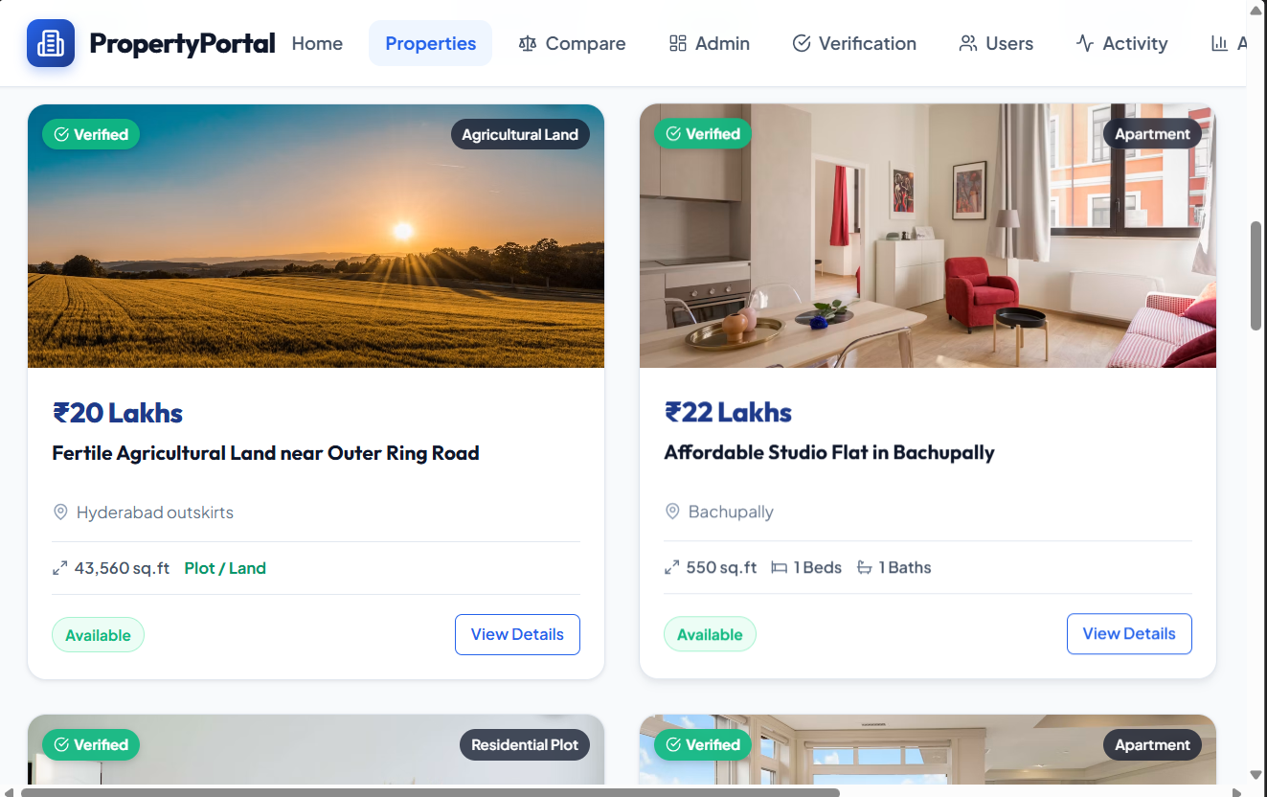
Property Search and Filtering Interface
Users can search by keyword and narrow results using supported attributes. Filter combinations should be applied predictably. Empty results should offer a way to clear or adjust filters.

Property Details
The detail page consolidates the description, key facts, amenities, location information, media, status, and inquiry action. Claims such as approvals, completion status, or developer credentials should only be displayed when supported by verified source data.

Project Comparison
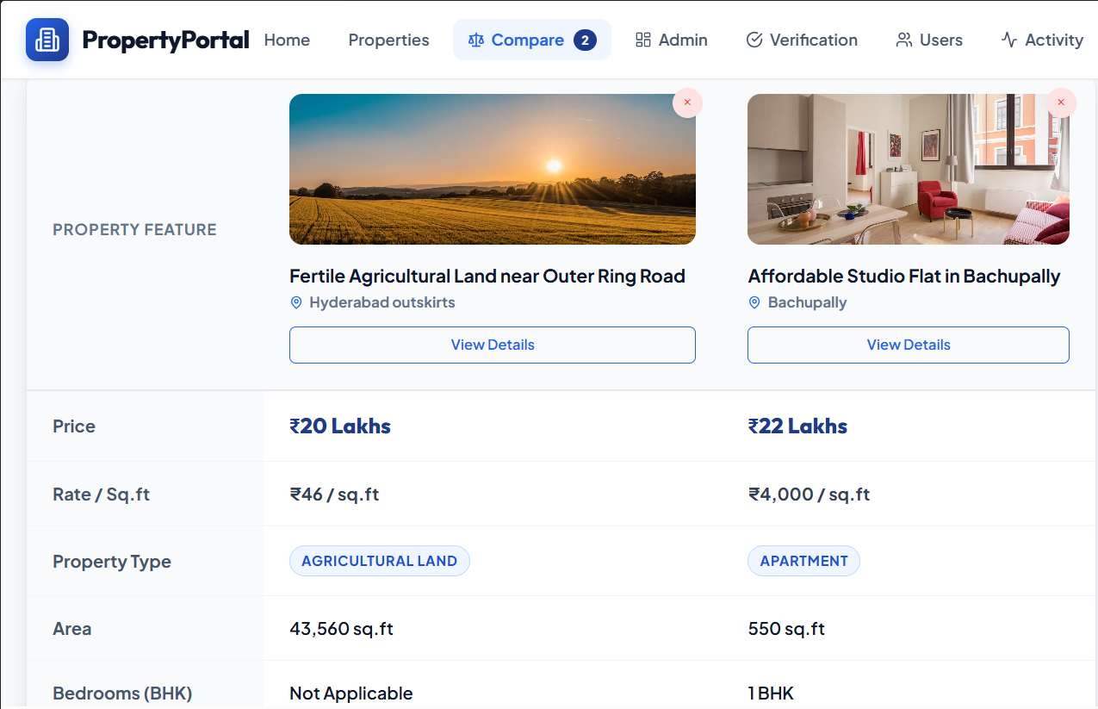 Property Comparison Interface
The comparison module helps users evaluate a selected set of properties against the same criteria. It should support adding and removing items, highlight differences without implying an unsupported recommendation, and handle missing attributes transparently.

Saved Properties and Inquiries
Authenticated users may maintain a shortlist. An inquiry form should collect only necessary contact details and the user’s message, validate inputs, and show a clear confirmation. Inquiry data must not be exposed to unrelated users.

Listing Administration
Administrators can add, edit, publish, unpublish, and archive listings. Validation should prevent malformed values. A review workflow can distinguish draft, pending review, published, and archived records.

Analytics
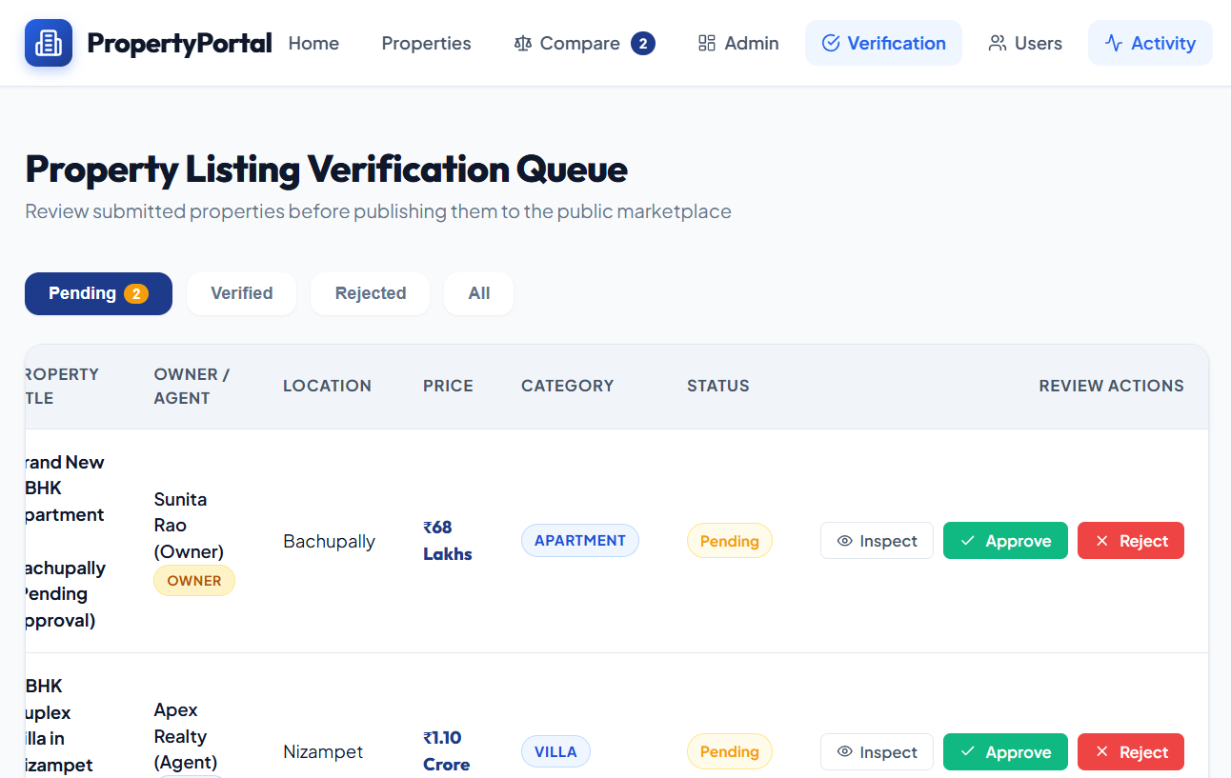
Admin Dashboard and Analytics
Buyer: browse properties, search and filter listings, view detailed information, compare properties, save favourites, and submit enquiries.
Owner: add and maintain property listings, update listing details, manage images and availability, and handle enquiries associated with owned listings.
Agent: manage assigned property listings and related enquiry workflows according to the permissions configured by the system.
Admin: manage users, verify or reject listings, monitor enquiries, review activity information, and access analytics through the administration dashboard.

Feature Workflow
Property discovery begins with the catalogue and filter controls. After a user selects a listing, the property detail page presents the available information. Selected properties can be compared using common attributes. Authenticated users can save properties and submit enquiries. Management users can create or modify listings, while administrative users can review and control listing status. Analytics summarize the records available in the application and should be interpreted according to the underlying dataset.

Analytics should summarize the available catalogue, not claim to represent the entire real-estate market unless the data source justifies that conclusion. Examples include counts by type, price-band distribution, average or median asking price, and inquiry trends. Metrics should disclose filters, dates, and missing-data handling.

IMPLEMENTATION APPROACH

Development Sequence
A practical implementation sequence is: establish the repository and environment; define the data model; build listing CRUD; implement catalogue and detail views; add search and filters; implement comparison; add authentication and user actions; build analytics; add tests; and prepare deployment documentation.

API and Validation
Endpoints should use consistent naming and response structures. Validate all user-controlled fields on the server. Use pagination for large result sets. Return useful client errors for invalid inputs and avoid exposing stack traces or secrets in production responses.

Frontend State
Keep filter state, selected comparison items, and form state predictable. Avoid duplicating the same listing data in multiple unrelated stores. Loading, empty, error, and success states should be designed as first-class interface states.

Analytics Computation
Define each metric before implementing it. For example, “active listings” should specify whether pending-review records are excluded. Average price should specify its currency and treatment of missing or outlier values. Where the data supports it, median price may be more robust than the mean.

Configuration and Secrets

Module-Wise Implementation
The implementation is divided into frontend components, application services, database operations, and role-aware pages. The frontend source contains reusable components such as PropertyCard, PropertyFilterBar, BudgetFilter, Pagination, AdminRoute/ProtectedRoute, and page-level views. The backend contains the server and database-access logic required to process requests and persist application data.

Frontend Logic and State Management
The React frontend maintains user input and application state for property filters, pagination, selected properties, favourites, and forms. For example, the PropertyFilterBar receives the current filter state and calls the filtering handler when a field changes. This keeps the filter controls synchronized with the property results and allows the application to reset the page when filters change.

API Integration
The frontend communicates with the Node.js/Express backend through HTTP API requests. A typical request carries search, filter, listing, authentication, favourite, or enquiry information to the server. The backend validates the request, performs the required MySQL operation, and returns the result to the React interface. This separation keeps database access on the server rather than exposing database credentials to the browser.

Authentication and Authorization
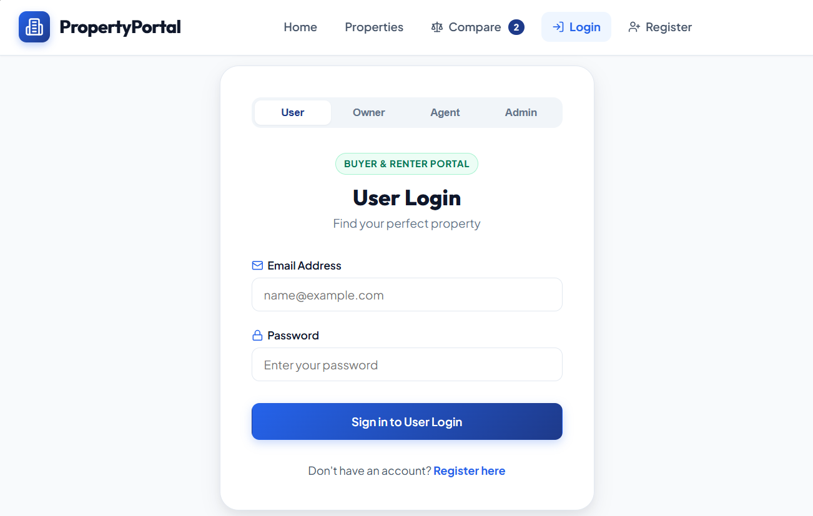
Authentication establishes the identity of a user, while authorization determines which operations the user is permitted to perform. The PropertyPortal design uses role-aware access for Buyer, Owner, Agent, and Admin accounts. Protected frontend routes improve navigation control, while authorization must also be enforced on backend endpoints so that a user cannot gain access simply by changing a browser request.

Use environment configuration for database URLs, API keys, and email credentials. Provide an example environment file with placeholder values, but never commit real credentials. Document migration and seed-data steps.

TESTING AND VALIDATION

Testing Strategy
Testing should cover unit-level validation and business rules, API integration, database constraints, user workflows, responsive presentation, and regression checks. Test results in the final submission should reflect runs actually performed by the team.

Representative Test Cases
ID | Scenario | Expected result
TC-01 | Search by a known keyword | Matching listings appear; unrelated records are excluded according to search rules.
TC-02 | Apply price and location filters | Every returned listing satisfies both active filters.
TC-03 | Set minimum price greater than maximum | Validation message appears; invalid query is not silently accepted.
TC-04 | Compare listings with missing fields | Missing values are labelled; they are not displayed as zero.
TC-05 | Unauthorized user opens admin action | Request is denied by server-side authorization.
TC-06 | Submit inquiry with required fields missing | Form identifies required fields and does not create an invalid inquiry.
TC-07 | Archive a listing | Listing status changes and public visibility follows the defined policy.
TC-08 | Reconcile dashboard count with dataset | Metric matches the documented query and selected filters.
Test status and actual results must be filled in from execution evidence.

Acceptance Criteria
A successful demonstration should show that users can find listings with combined filters, inspect details, compare selected projects, and submit an inquiry; administrators can maintain listings subject to validation; and analytics are consistent with the underlying dataset. Access-control checks should confirm that unauthorized users cannot invoke administrative actions.

Evidence

API Testing
Postman can be used to test the backend endpoints independently of the React interface. Typical checks include login or authentication requests, property listing retrieval, filtering requests, listing creation or update, favourite operations, enquiry submission, and administrative operations. The response status, response body, validation behavior, and authorization response should be recorded for each endpoint actually tested.

Integration Testing
Integration testing verifies the communication among the React frontend, Express backend, and MySQL database. For example, a property created through an authorized management interface should be persisted in MySQL and subsequently appear in the catalogue according to its publication and verification state. Similarly, an enquiry submitted through the frontend should be stored by the backend and visible only to users with the appropriate permission.

Testing Tools
The project can be tested using the browser developer tools for frontend inspection, Postman for API testing, MySQL tools for database verification, and manual browser testing for user workflows. Automated testing tools should only be listed in the final report when the team has actually used them.

Test Result Recording
The sample report emphasizes recording actual test outcomes rather than assuming that a test passed. Therefore, the final submission should include the date of execution, test case ID, input or precondition, expected result, observed result, status, and any corrective action. No numerical pass percentage should be claimed unless it is supported by executed test evidence.

Keep test cases, screenshots, console output, and known-issue notes in the repository. For each failed test, record the observed behavior, expected behavior, severity, and resolution or workaround. Do not report a test as passed without evidence.

SECURITY, PRIVACY AND DATAQUALITY

Authentication and Authorization
Authentication identifies a user; authorization determines what that user may do. Administrative operations must be protected on the server. Role checks should be applied to every privileged endpoint, not only by hiding interface controls.

Input and Output Safety
Validate and normalize input, use parameterized database operations or safe ORM methods, encode untrusted text on output, and validate uploaded file types and sizes. Apply rate limits to sensitive endpoints where appropriate.

Privacy
Collect only information needed for accounts and inquiries. Restrict access to contact details, define retention expectations, and avoid displaying personal information in public listing pages.
Use secure transport and appropriate password handling if local authentication is implemented.

Listing Verification
Property data can be inaccurate or outdated. Maintain source and last-updated metadata where feasible. Clearly distinguish verified facts, owner-provided details, and unverified promotional statements. Provide a correction or report-listing path if included in scope.

Analytics Integrity
Analytics should be reproducible from defined queries. Do not treat missing prices as zero, mix currencies without conversion, or compare area values expressed in different units. Explain the dataset coverage and any exclusions.

DEPLOYMENT AND OPERATIONS

Local Setup
The repository should include prerequisites, installation commands, environment-variable setup, database initialization, seed-data instructions, and the command used to start the application.
These instructions must be tested on a clean environment before submission.

Production Considerations
A deployment may require a hosted application service, managed database, HTTPS, environment secrets, backups, logging, and a defined update process. The selected host and exact configuration should be documented only after they are chosen and tested.

Monitoring and Backup
Capture application errors without logging sensitive data. Back up persistent records and document how restoration would be performed. Monitor availability and database capacity if the portal is deployed beyond a local demonstration.

Release Checklist

Local Deployment / Execution Steps
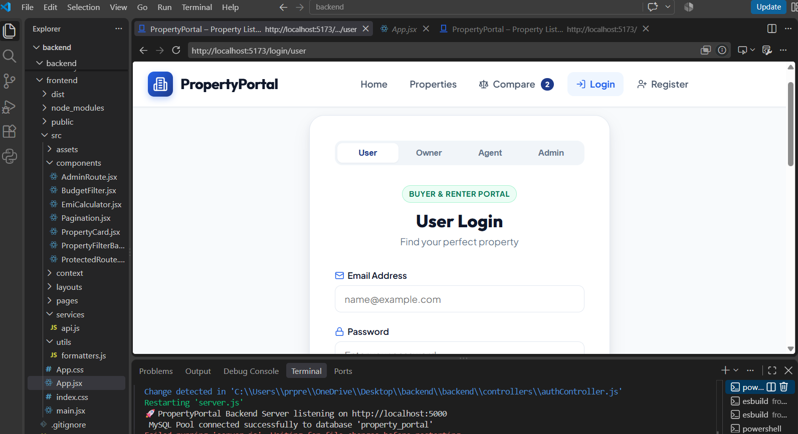
PropertyPortal Backend and MySQL Running Successfully
1. Open the project in Visual Studio Code. 2. Open a terminal in the main project folder. 3. Start the backend from the nested backend directory using the project’s configured development command. 4. Confirm that the server reports that it is listening on http://localhost:5000 and that the MySQL pool connects to the property_portal database. 5. Open a second terminal and move to the frontend directory. 6. Run npm install if dependencies have not yet been installed. 7. Run npm run dev. 8. Open the Vite development URL, normally http://localhost:5173, in a browser. 9. Keep both backend and frontend terminals running while testing the application.

Environment Configuration
Database connection details and other sensitive configuration values should be stored in environment variables rather than directly in source code. The repository may contain an .env.example file containing placeholder variable names. Real passwords, API keys, and production credentials should remain outside version control.

Hosting Status
The current project information supports a local development environment. Public cloud hosting should not be described as completed unless the team has actually deployed and verified the application on a hosting platform. If deployment is performed later, the report should record the frontend host, backend host, database host, environment configuration, domain, HTTPS configuration, and deployment date.

Confirm configuration, migrations, seed-data policy, role permissions, responsive layout, test results, dependency versions, HTTPS, backup strategy, and the removal of demo credentials before a public release.

CHALLENGES AND LIMITATIONS

Data Availability
A comparison tool is only as reliable as the underlying listing records. Missing or inconsistent price, area, possession, and amenity fields can limit comparison quality.

Data Freshness
Real-estate listings can change quickly. Without an update workflow and a visible last-updated date, users may rely on stale information.

Comparability
Different projects may quote different area definitions, fee inclusions, or possession descriptions. The portal should avoid presenting values as directly comparable unless units and definitions are aligned.

Scope Limitations
The portal does not itself establish legal ownership, guarantee construction quality, validate all regulatory claims, or provide professional financial advice. Maps and external notifications may be unavailable if third-party credentials or services are not configured.

Mitigation

Development Issues and Solutions to Document
The final report should record project-specific issues that were actually encountered. Relevant categories for this portal include database connection problems, inconsistent property data, filter-state handling, role-based access control, API validation, image or document handling, and synchronization between frontend state and backend records. Each issue should be documented with the observed problem, cause where established, solution applied, and whether the issue remains.

Current Limitations / Known Bugs
Only verified limitations should be listed as current bugs. The present report identifies incomplete or changing listing data, data freshness, differences in property definitions, and dependence on optional external services as limitations. These limitations affect the interpretation of comparisons and analytics and should be communicated to users.

Use structured fields, data validation, visible source/update information, transparent missing-value handling, and a clear disclaimer. Expand integrations only when their data rights, reliability, and maintenance requirements are understood.

FUTURE ENHANCEMENTS

Map-Based Discovery
Add a map view with clustering, location search, and distance-based filters, subject to reliable geocoding and appropriate map-service terms.

Saved Searches and Alerts
Allow users to save filter combinations and receive notifications when matching listings are added or updated, with consent and unsubscribe controls.

Improved Data Quality
Add duplicate detection, bulk import validation, field completeness indicators, source tracking, and an administrative review queue.

Personalization
A user-controlled recommendation feature could rank listings against explicitly selected preferences. It should explain the attributes used and avoid treating incomplete data as evidence of poor suitability.

Market Analytics
With a sufficiently broad, lawful, and representative dataset, the system could support time-series analysis and geographic summaries. Any market-level conclusion would need coverage checks and careful methodology.

CONCLUSION

Summary
Property Listing Management & Analytics Portal for Real Estate is designed to organize property information into a single searchable catalogue and support structured comparison, shortlisting, inquiries, listing administration, and descriptive analytics. Its value depends on consistent data definitions, clear user workflows, and transparent handling of missing or unverified information.

Outcome

What Was Achieved
The project establishes a full-stack PropertyPortal that connects a React-based user interface with a Node.js/Express backend and MySQL database. The documented feature set covers property discovery, filtering, comparison, favourites, enquiries, listing management, role-based access, administrative verification, and analytics. The local environment has been demonstrated with the backend listening on port 5000 and successfully connecting to the property_portal MySQL database; the frontend is intended to run separately through the React/Vite development server.

Skills Learned During Development
The project provides practical experience in full-stack web development, React component design, JavaScript programming, REST-style API communication, Node.js and Express.js backend development, relational database design and SQL, authentication and authorization concepts, form and input validation, role-based application design, debugging, testing, environment configuration, and project documentation. It also demonstrates how frontend, backend, and database layers are combined into a single software system.

The report establishes a design and validation framework for the project. The final claim about implemented features, performance, and deployment must be based on the team’s actual code, tests, and demonstration. A well-documented release should include reproducible setup instructions, test evidence, and a clear account of known limitations.

REFERENCES
- K. L. University, “K L (Deemed to be) University,” institutional website and academicinformation. Consult the official source for current institutional details.
- OWASP Foundation, “OWASP Top 10: Web Application Security Risks,” for general webapplication security guidance.
- W3C, “Web Content Accessibility Guidelines (WCAG) 2.2,” for accessibility principles andsuccess criteria.
- PostgreSQL Global Development Group, “PostgreSQL Documentation,” if PostgreSQL isselected as the project database.
- MDN Web Docs, “HTTP,” “HTML,” “CSS,” and “JavaScript” documentation, whereapplicable to the chosen implementation.
- The official documentation for the frontend framework, backend framework, database,charting library, and hosting platform actually used by the project. Add exact titles, versions, URLs, and access dates before submission.
- Property listing source materials and data dictionaries used by the team. Record the publisher,retrieval date, permitted use, and any limitations for each dataset.

APPENDIX A – Screenshots of the website

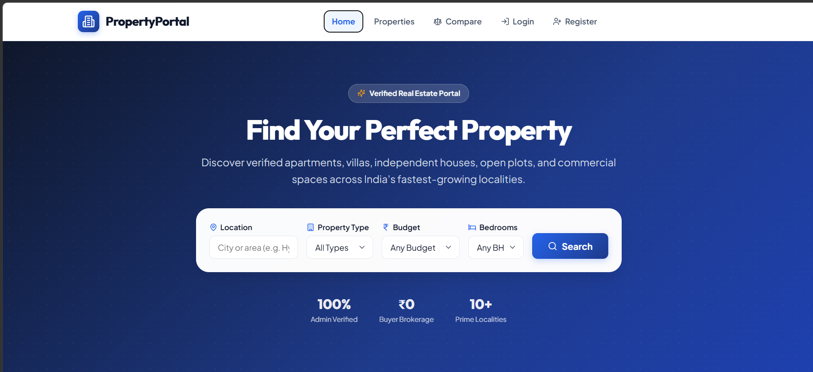
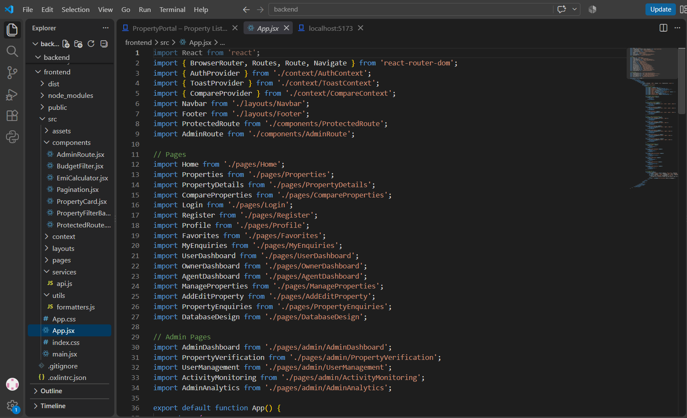

APPENDIX A1 – Installation and Setup Guide
Prerequisites: Node.js and npm installed, MySQL Server running, the project source code available locally, and a modern web browser.
Backend setup: Open a terminal in the project root, enter the nested backend directory, install dependencies if required, and start the configured server command. Confirm the message indicating that the PropertyPortal backend is listening on http://localhost:5000 and that the MySQL pool has connected to the property_portal database.
Frontend setup: Open a second terminal, enter the frontend directory, install dependencies if required using npm install, and start the development server using npm run dev. Open the displayed local URL, normally http://localhost:5173.
The backend terminal and frontend terminal must remain running simultaneously while the application is being tested.

APPENDIX A2 – Project Structure
The frontend follows a component-based structure. The visible project contains folders such as src/components, src/context, src/layouts, src/pages, src/services, and src/utils, along with App.jsx, main.jsx, CSS files, package.json, and other configuration files. The backend is maintained separately and contains the server-side application and database connection logic.

APPENDIX A3 – User Guide
Buyer: open the catalogue, search or apply filters, inspect property details, compare selected properties, save favourites, and submit an enquiry. Owner/Agent: sign in, open the management area, create or edit listings, update available information, and review enquiries. Admin: sign in to the administration area, manage users, review and verify listings, monitor enquiries and activity, and inspect analytics.

APPENDIX B — DATA DICTIONARY
Field | Meaning | Validation guidance
Price | Asking price for the listing | Non-negative numeric value; currency required.
area_value | Area measurement | Positive numeric value; pair with area_unit.
property_type | Category of property | Controlled vocabulary where possible.
Status | Lifecycle state | Use documented states such as draft, published, archived.
possession_date | Expected/actual possession date | Use date type and clarify whether estimated.
updated_at | Last update timestamp | Set consistently on successful updates.
verification_state | Review state of listing claims | Do not imply verification without evidence.

APPENDIX C — SUBMISSION CHECKLIST
- Replace any illustrative content with details matching the implemented application.
- Record the actual technology stack and dependency versions.
- Attach screenshots of the actual interface and diagrams that match the implementation.
- Run the listed tests and record actual outcomes, including failures.
- Verify all references and add URLs/access dates where required.
- Confirm team names, IDs, guide details, academic year, and university formatting with thedepartment.
- Ensure the final report does not claim features, analytics, or deployment that are not present inthe submitted project.
- 